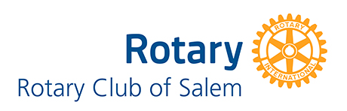
2020-2021 GoodWorks Small Grant Window is now open!
Do you know of a deserving organization looking for grant funding?
Our club is once again opening its small grant window, offering several
$500 - $1,500 grants to deserving non-profit organizations in our community.
They need to act fast! The deadline to apply is April 3rd, 2020.
Eligible projects for consideration are those that directly or indirectly foster, develop, promote,
and encourage the health, education, and the general welfare of primarily youth in the city of Salem
and the surrounding area. Interested applicants should submit proposals for a project focused
on service projects performed by Salem area non-profit organizations.
For details, head to www.rotaryclubofsalem.com
(You will find the link to the application under “News” and then “Blog” on the webpage.)
For questions, drop us a line at info@rotaryclubofsalem.com

